**Manually clearing payments**

The clearing of payments can be done based on 2 things: remittance advice in the mailbox or pulling a list from SAP

**Customer sends us a payment document in the mailbox**

1. Go to SAP > Receivables > Customer Accounts
2. Search for the client and click on the account ID
3. Find the payment in the open items and select clear manually
4. Select the invoice or invoices that need to be reconciliated with the payment and click clear
5. The posting date and document date can be the date we received the document

**Aging list from SAP**

Go to SAP > Receivables > Reports: List

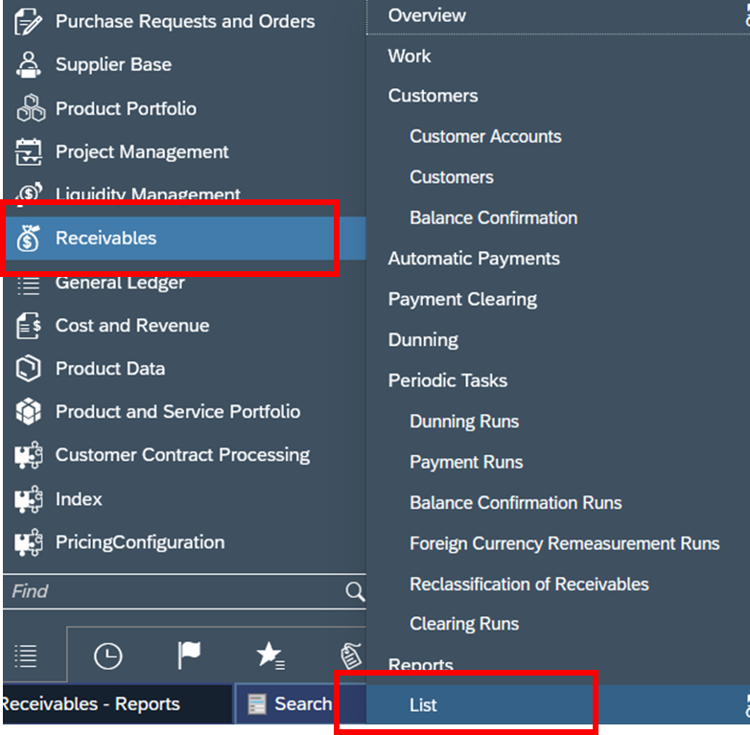

Choose the Aging List for Receivables

In the selection tab, make sure you are pulling the list for all 4 entities > Start report

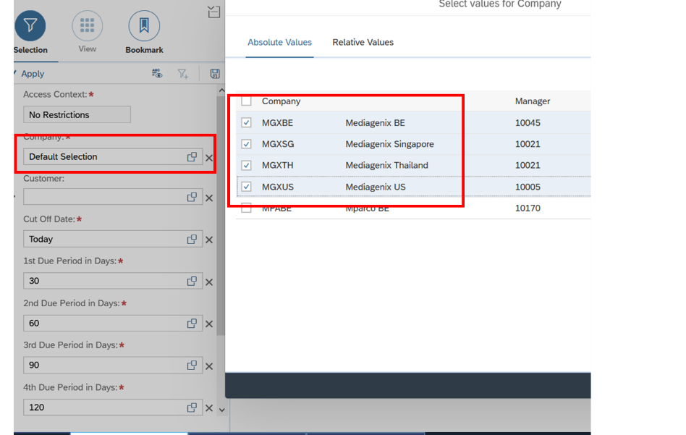

In the View tab, we will add an extra parameter to filter out the payments > Row fields + Doc Number and document type

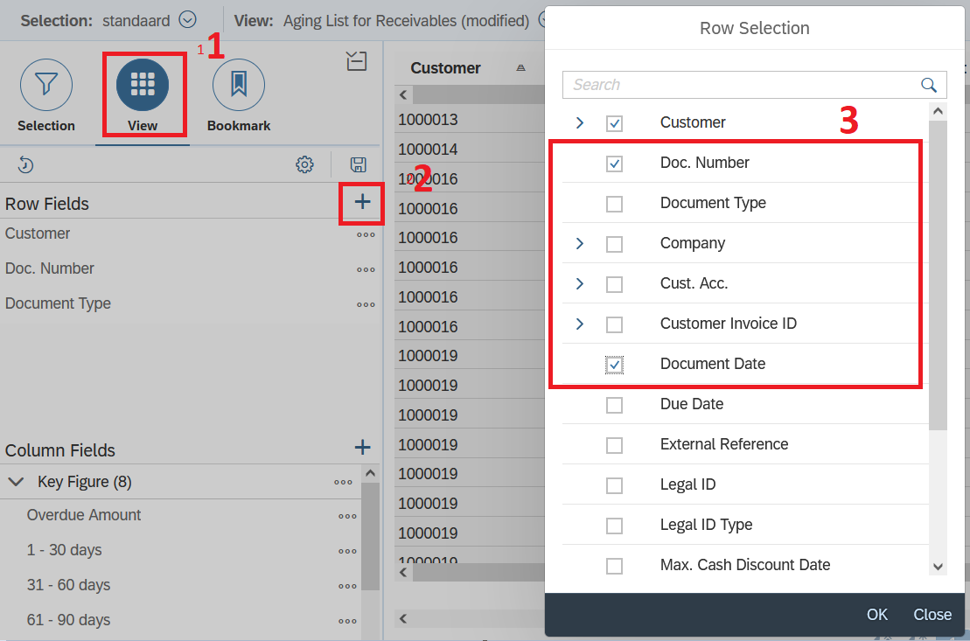

Download the report and open it in Excel

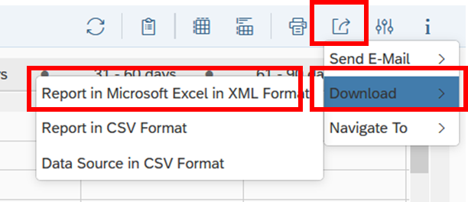

Put a filter on your table and only take the payments (all the numbers that are not invoice numbers) into consideration, remove all of the invoice numbers

Follow the first to 5th step

The posting date and document date should be the date that the clearing was done manually

Checking:

* 1. When you downloaded the file, filter on “Payment”,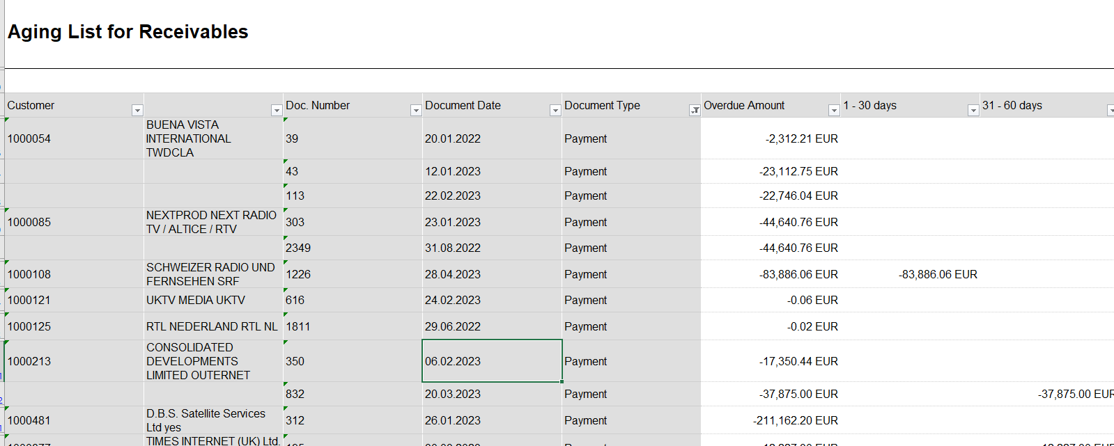

then check all clients in receivables-customers (except Mediagenix)

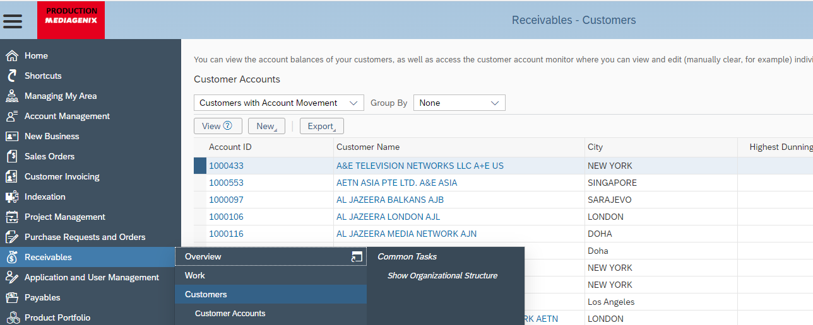

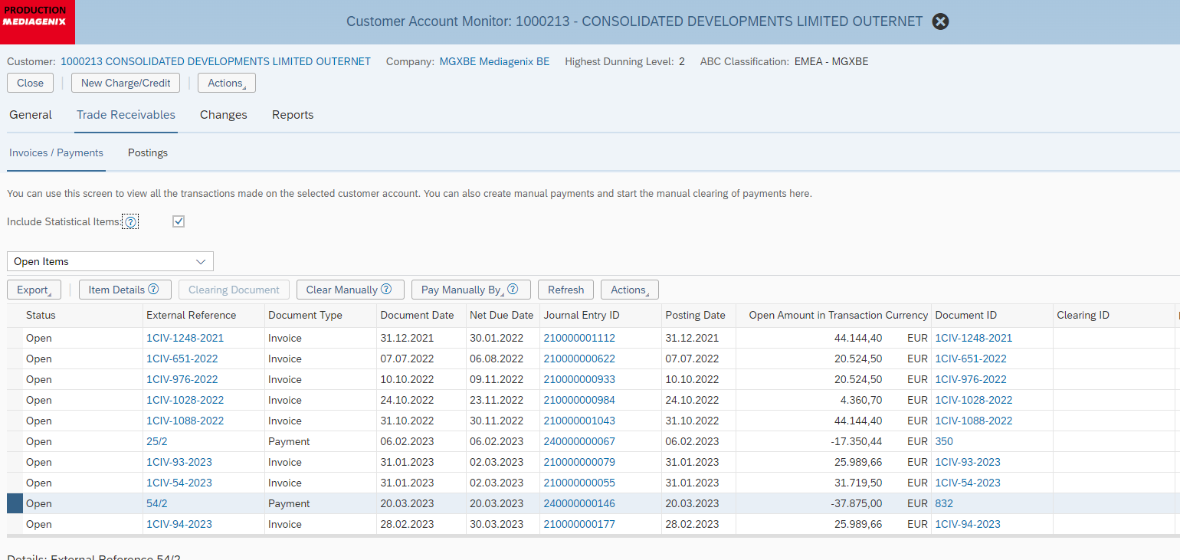

Click on the line “Payment” (external reference)

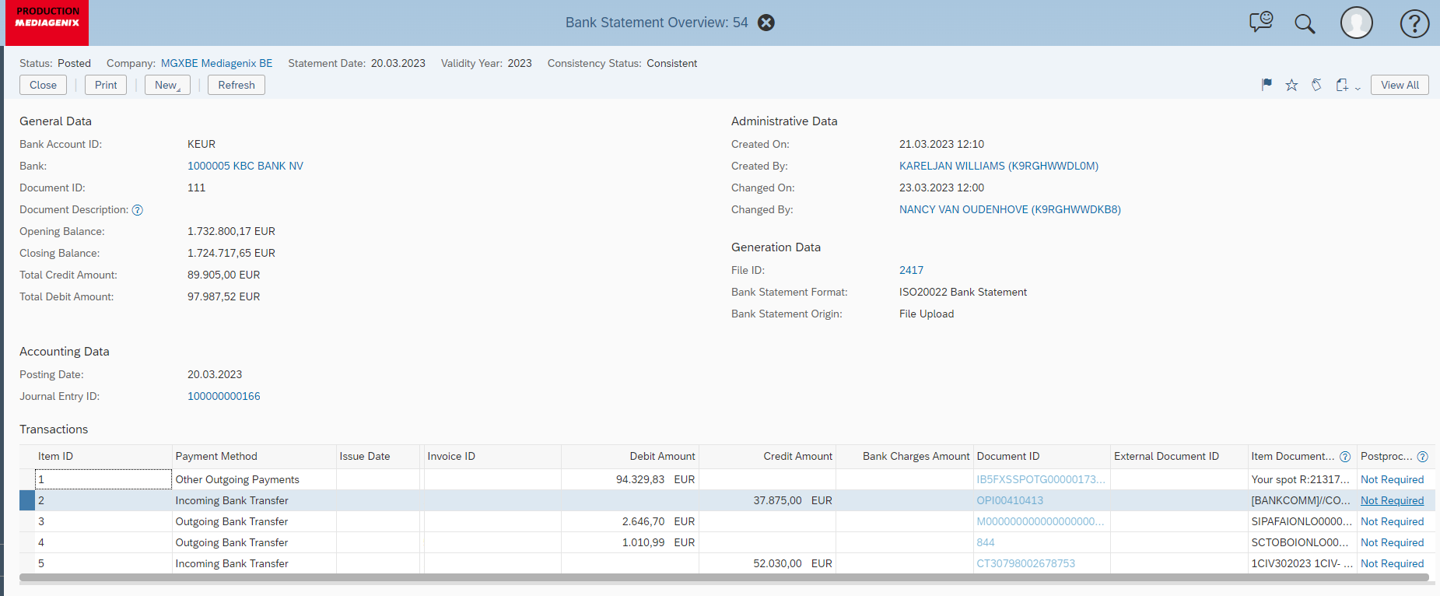

On 2 line – Not required

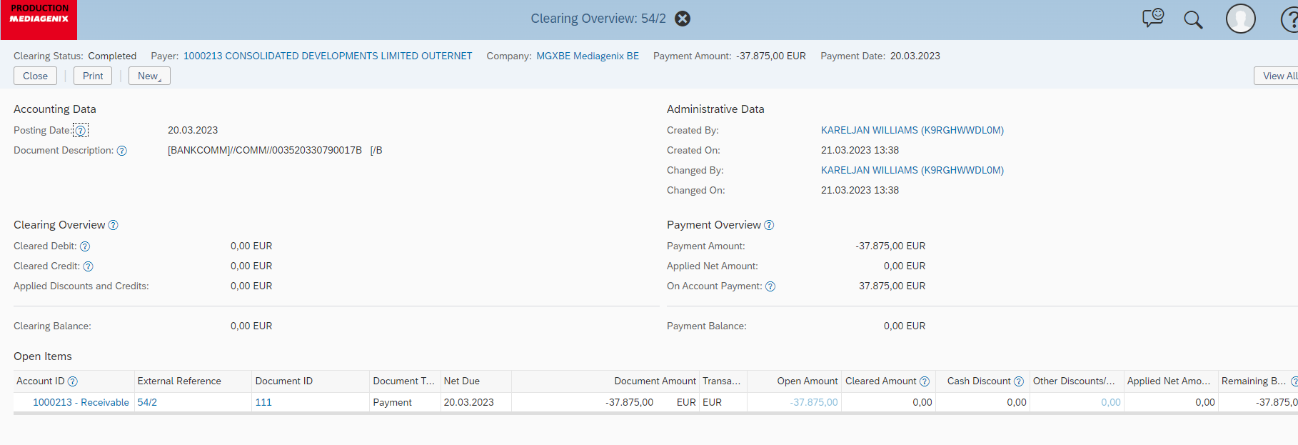

Check which invoices were paid

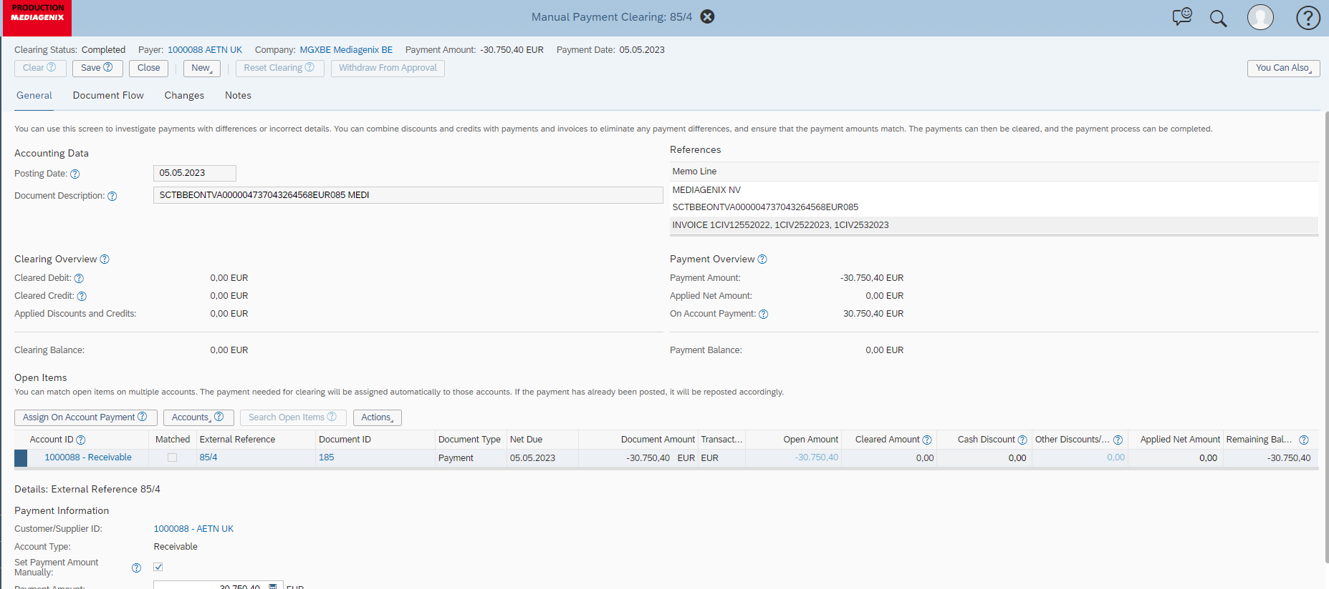

Go back to the client

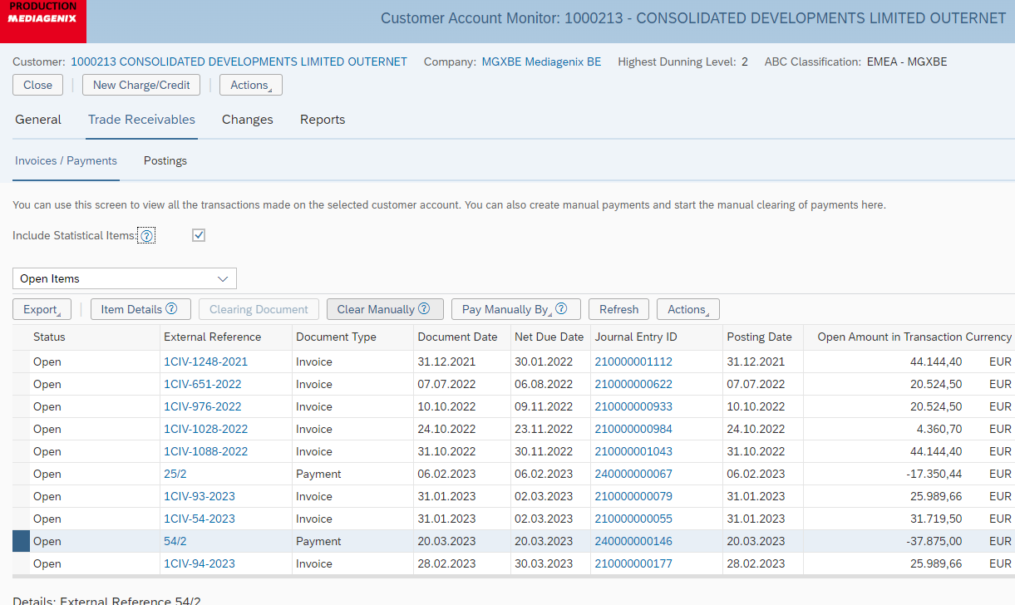

Clear manually

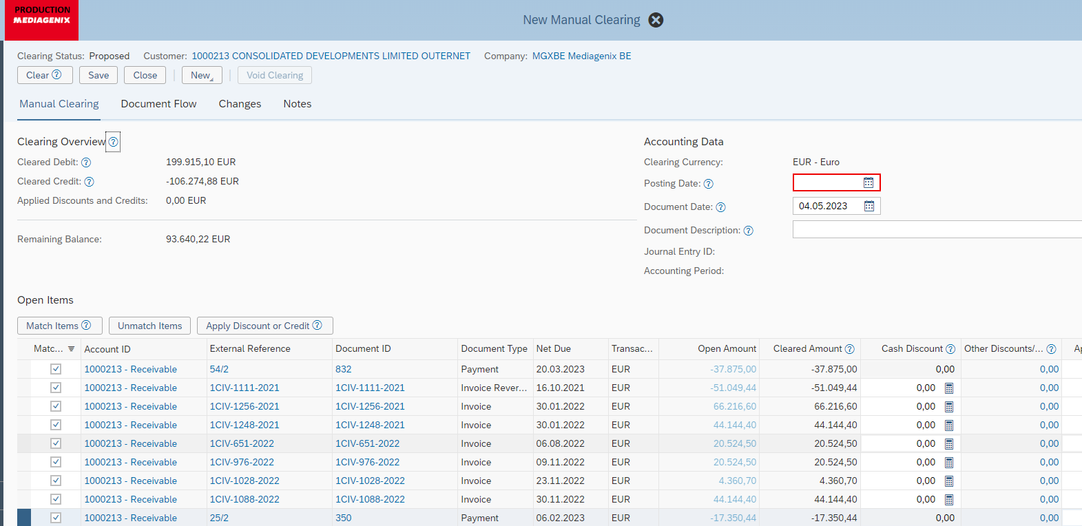

Tip every invoice that should be cleared(client paid), amount should be 0, the posting date the same as document date and clear